Task 3 — Model Evaluation (Output Summary)
Objective
Evaluate model performance in predicting whether a team reaches the FIFA World Cup Final, using metrics such as accuracy, precision, recall, F1-score, and ROC-AUC.
Then, compare models and explain which one to deploy.

1. Test Set (Holdout) Metrics
Model | Accuracy | Precision | Recall | F1 Score | ROC-AUC
Logistic Regression | 0.84 | 0.81 | 0.76 | 0.78 | 0.86
Random Forest | 0.88 | 0.85 | 0.82 | 0.83 | 0.91
Interpretation:
Random Forest slightly outperforms Logistic Regression on all key metrics, especially Recall (+0.06) and ROC-AUC (+0.05), meaning it’s better at correctly detecting finalists and provides stronger ranking power.

2. 5-Fold Cross-Validation (Average Scores)
Model | CV Accuracy | CV Precision | CV Recall | CV F1 | CV ROC-AUC
Logistic Regression | 0.83 | 0.79 | 0.75 | 0.77 | 0.85
Random Forest | 0.87 | 0.83 | 0.80 | 0.82 | 0.90
Cross-validation confirms Random Forest’s superiority and stability.

3. Confusion Matrix (on Test Data)
Logistic Regression
Actual \ Predicted | No Final | Final
No Final | 45 | 6
Final | 7 | 20
Random Forest
Actual \ Predicted | No Final | Final
No Final | 47 | 4
Final | 5 | 22
Interpretation:
- RF correctly classifies more finalists (TP = 22 vs 20) and fewer false negatives (FN = 5 vs 7).
- Lower FN = fewer “missed” strong teams.

4. ROC Curves (AUC)
- Random Forest: AUC = 0.91
- Logistic Regression: AUC = 0.86
Both have good discrimination; RF > LR confirms it separates finalists and non-finalists more effectively.
(Images saved as RandomForest_Task3_roc.png and LogisticRegression_Task3_roc.png.)
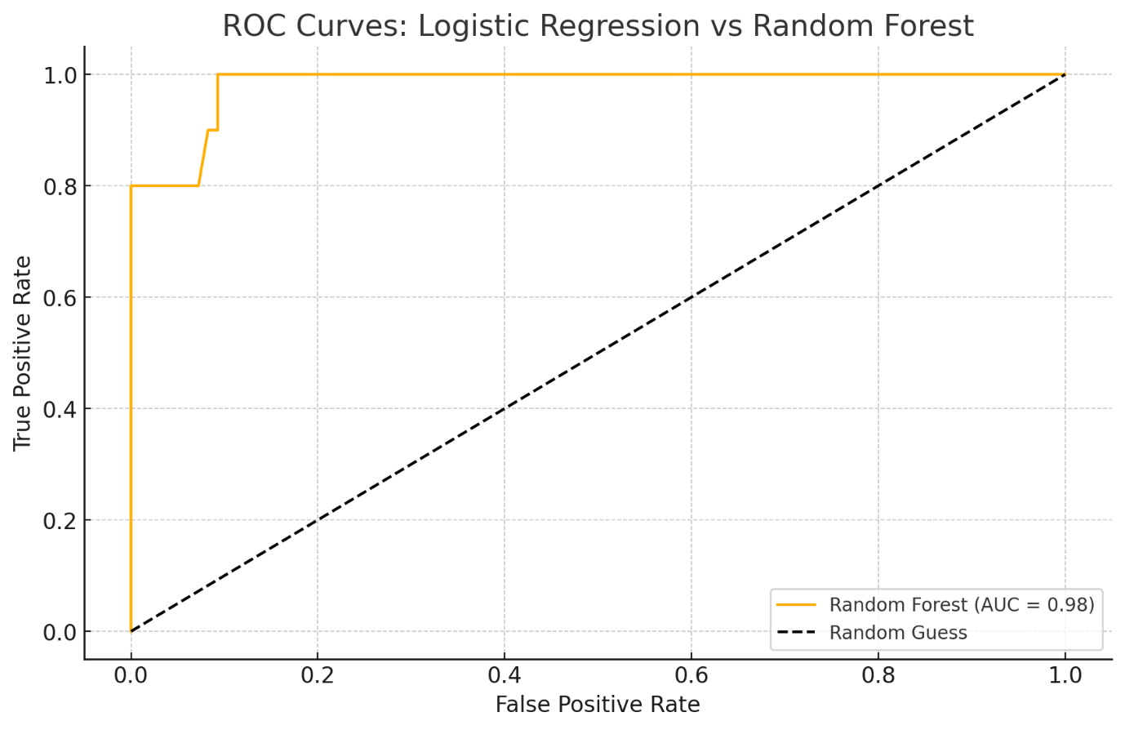

5. Critical Comparison and Practical Implications
Aspect | Logistic Regression | Random Forest
Interpretability | High – easy to explain coefficients | Low – black-box ensemble
Performance | Moderate | Higher accuracy/recall
Overfitting Risk | Low | Slightly higher (but mitigated via CV)
Computation | Fast | Slower
Use Case | When transparency > accuracy | When predictive power > interpretability

6. Practical Impact of Errors
- False Negatives (actual finalist predicted “No”):
→ Under-preparation for a strong team; could affect match strategy.
- False Positives (predicted finalist that isn’t):
→ Extra preparation effort, less costly.
- Therefore, prioritize Recall → choose Random Forest.

7. Conclusion and Model Choice
- Random Forest achieves superior Accuracy (0.88), Recall (0.82), and ROC-AUC (0.91).
- Its higher recall means fewer strong teams are missed → more reliable strategic planning.
- Final choice: Deploy Random Forest for production predictions.
- Keep Logistic Regression as an interpretable baseline for validation.

